Phạm Đăng Huy – 19H1040031 – Đề 1

Part 2 :

Question 2:

A,

SELECT s.city, SUM(s.commission) sum_of_commission

FROM salesman s

GROUP BY s.city

B,

SELECT * FROM customer c

JOIN salesman s on c.salesman_id = s.salesman_id

WHERE s.commission > 0.12

ORDER BY s.commission

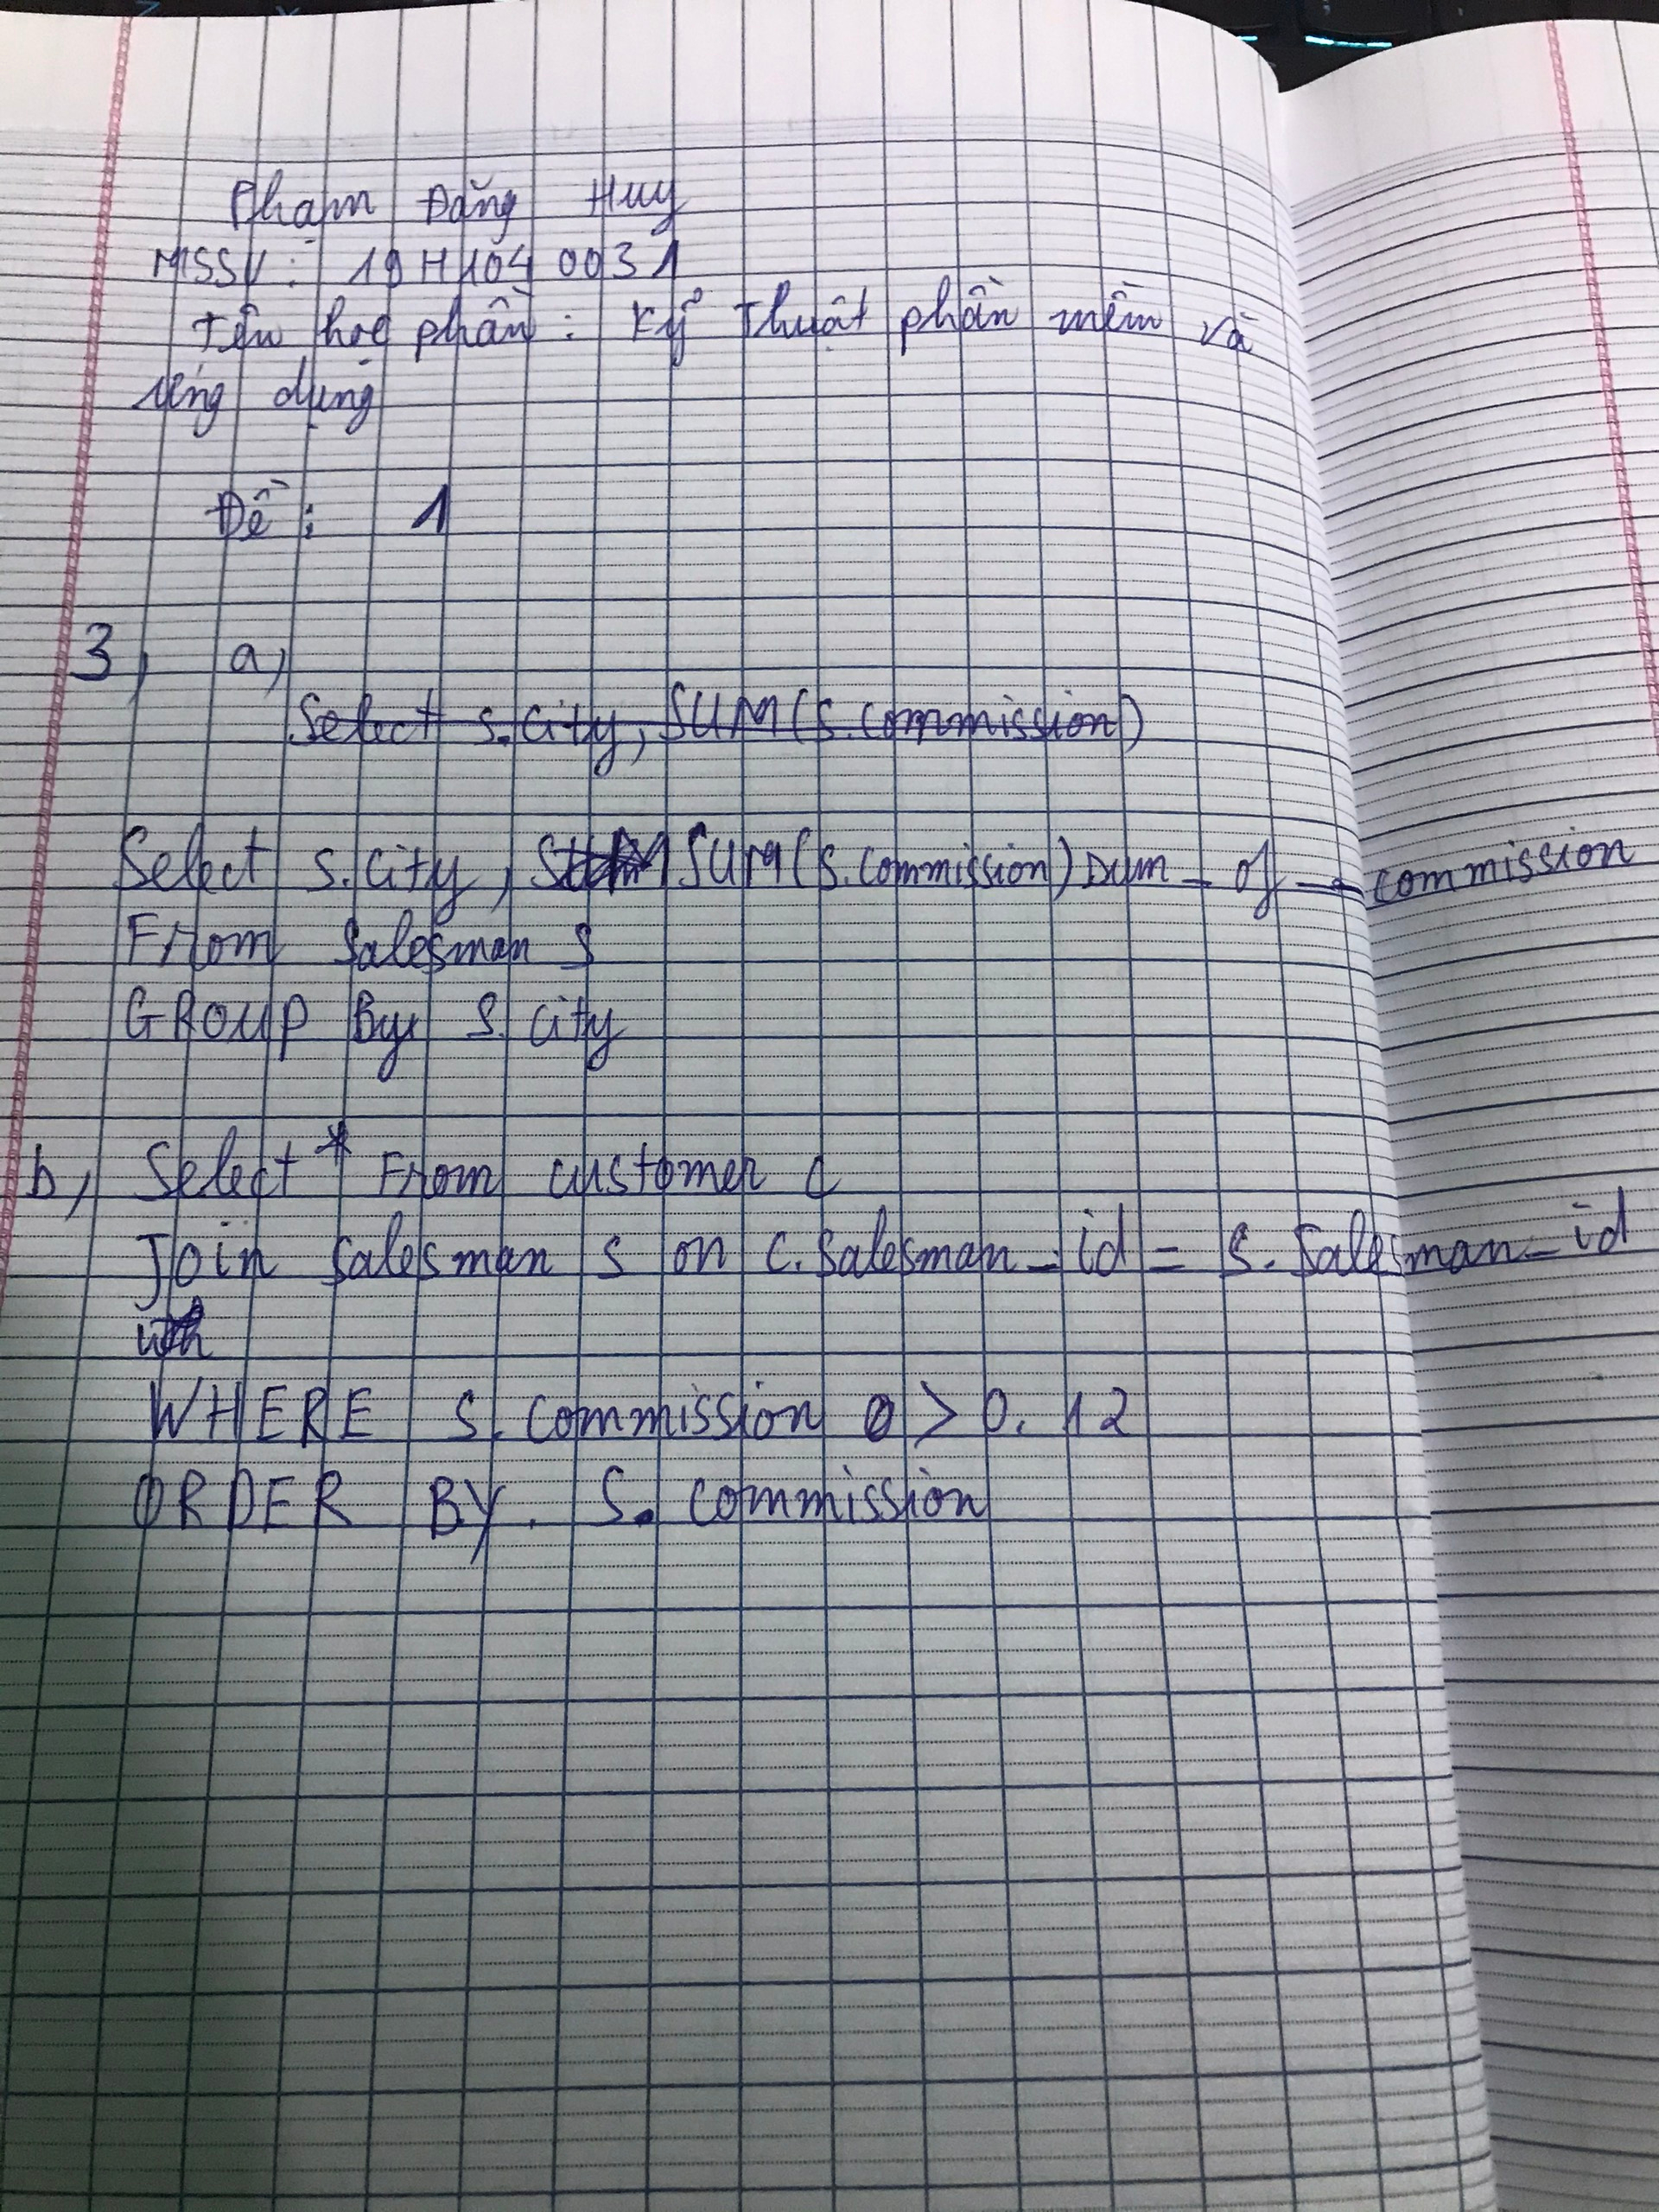

Q1: Part1:

A, def is_prime(n):

    if n < 2: return False

    for x in range(2, int(n ** 0.5) + 1):

        if not n % x: return False

    return True

arr = [int(x) for x in input().split()]

print(sum(1 for x in arr if is_prime(x)) >= 2)

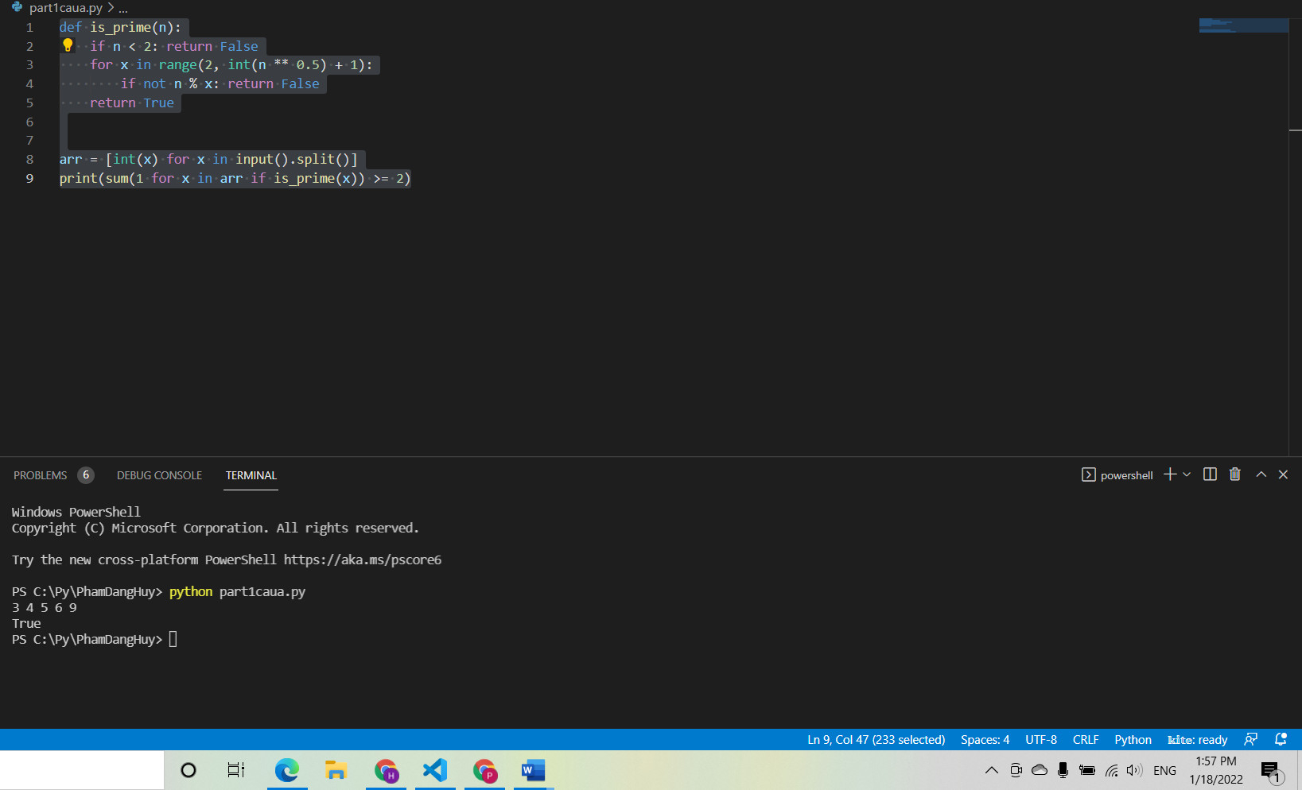

B, import pytest

def is_prime(n):

    if n < 2: return False

    for x in range(2, int(n ** 0.5) + 1):

        if not n % x: return False

    return True

@pytest.mark.parametrize(

    "arr,output",

    [([4, 6, 8, 10], 0),

     ([2, 4, 6, 8], 1),

     ([67, 113, 14, 77], 2)])

def test_prime(arr, output):

    assert sum(1 for x in arr if is_prime(x)) == output

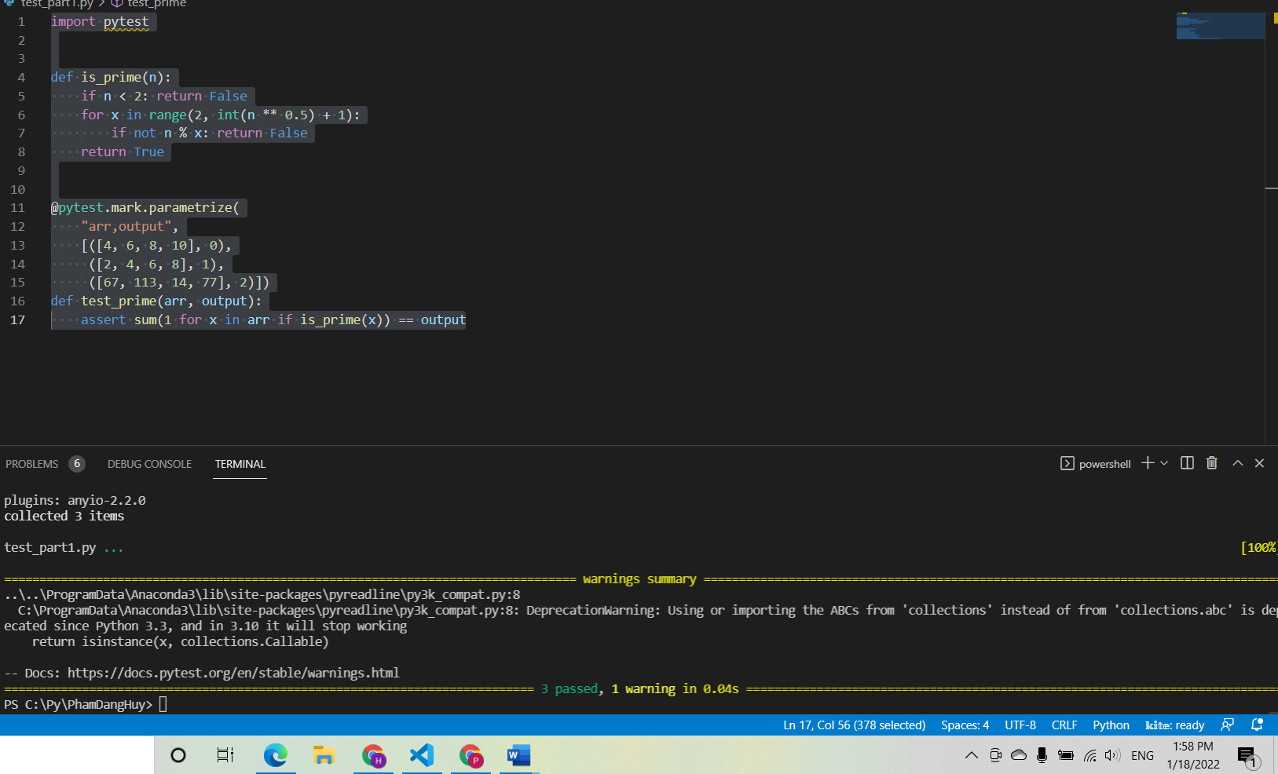

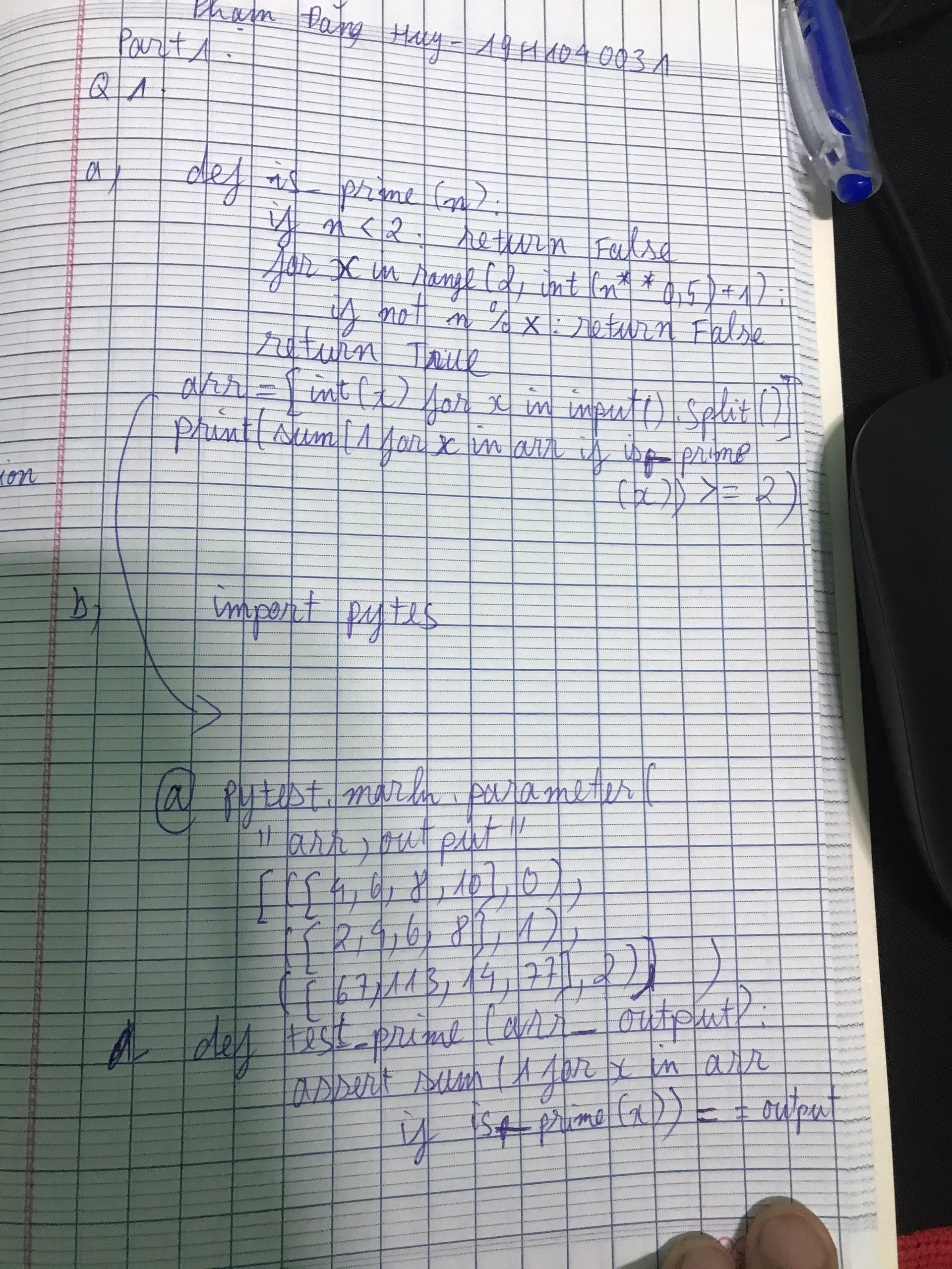

Part 2: Q2

class Real_Number:

    def __init__(self, real_number):

        self.real_number = real_number

    def module(self):

        return float(self.real_number)

class Complex_Number(Real_Number):

    def __init__(self, real_number, image_number):

        super().__init__(real_number)

        self.image_number = image_number

    def module(self):

        return (self.real_number ** 2 + self.image_number ** 2) ** 0.5

real = 6

img = -8

real_obj = Real_Number(real)

print(real_obj.module())

complex_obj = Complex_Number(real, img)

print(complex_obj.module())

